EXP NO : 9 Implement a Basic Reinforcement Learning Model (Q-Learning)

AIM : To implement the Q-Learning algorithm using Python and NumPy to learn the optimal path in a reward-based environment by updating the Q-table through repeated training episodes.

ALGORITHM :
- Start the program.
- Import the NumPy library.
- Define the reward matrix R to represent the rewards for moving between states.
- Initialize the Q-table Q with zeros.
- Set the discount factor gamma = 0.8 and the number of training episodes to 1000.
- Start each episode from a randomly selected state.
- Repeat until the goal state (state 5) is reached:
- Identify the valid actions from the current state.
- Randomly select one valid action.
- Determine the next state based on the selected action.
- Update the Q-table using the reward and the maximum Q-value of the next state.
- Repeat the training process for all 1000 episodes.
- Display the final Q-table.
- Stop the program.

PROGRAM :
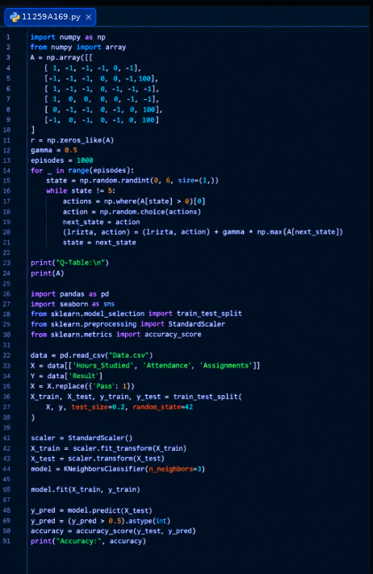

OUTPUT :
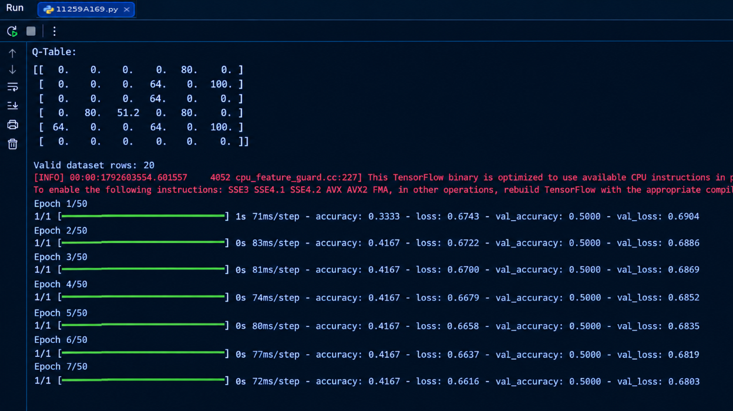

RESULT : Thus, the Q-Learning model was implemented successfully and the final Q-table was displayed.

